Project Report

1. INTRODUCTION
   1. Project overview:

In this project, we created a retail management application that helps the sales reps to make sure that the customers are satisfied with the products and service they buy

We created two applications, they are

* A sales app
* A service app
  1. Purpose:
* The sales app helps the sales reps to store the customers data
* And the service app helps the sales reps to provide support to their customers

1. Problem Definition and Design Thinking

2.1 Empathy map :

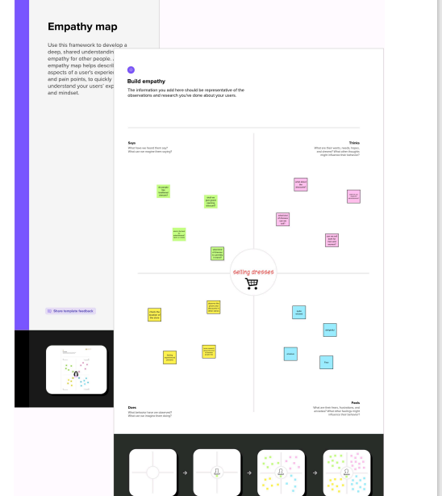

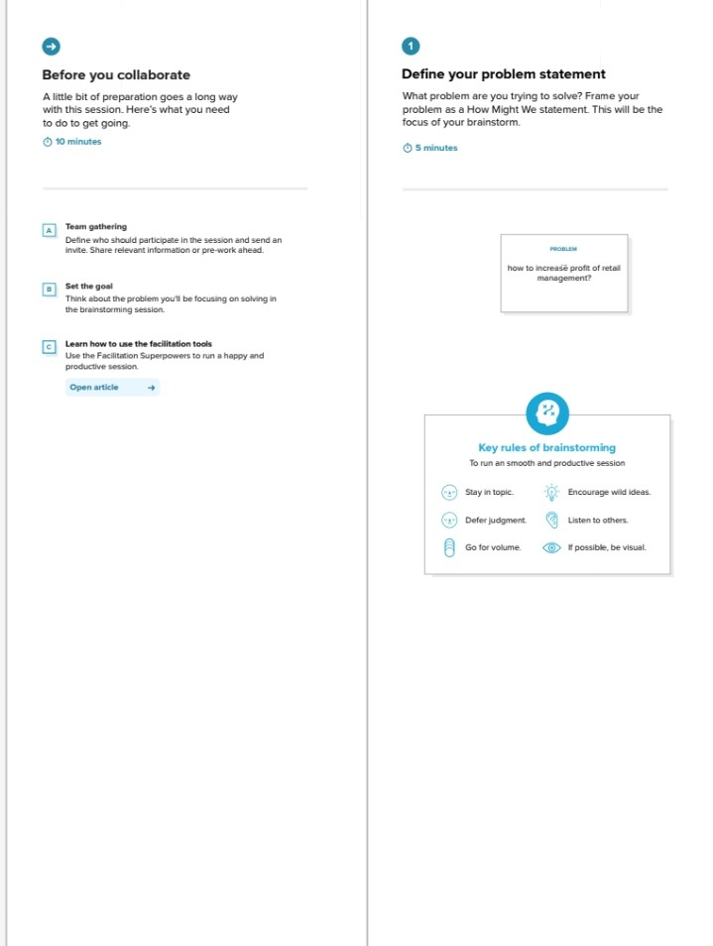2.2 Ideation and Brainstorming map:

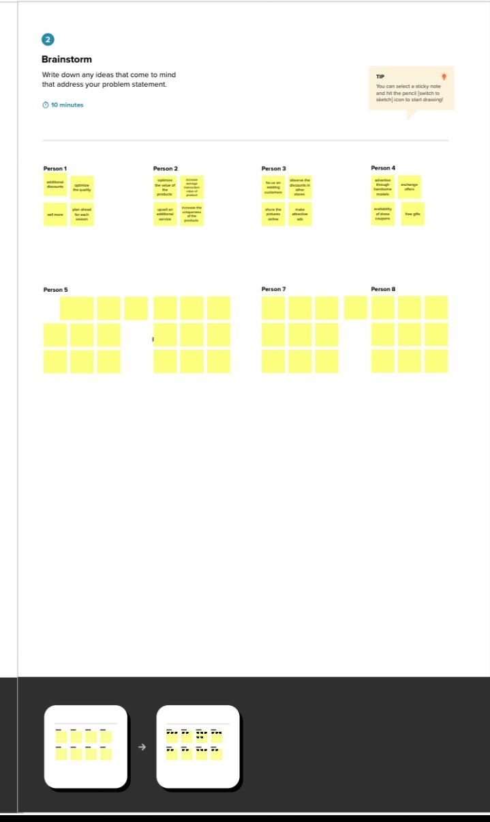

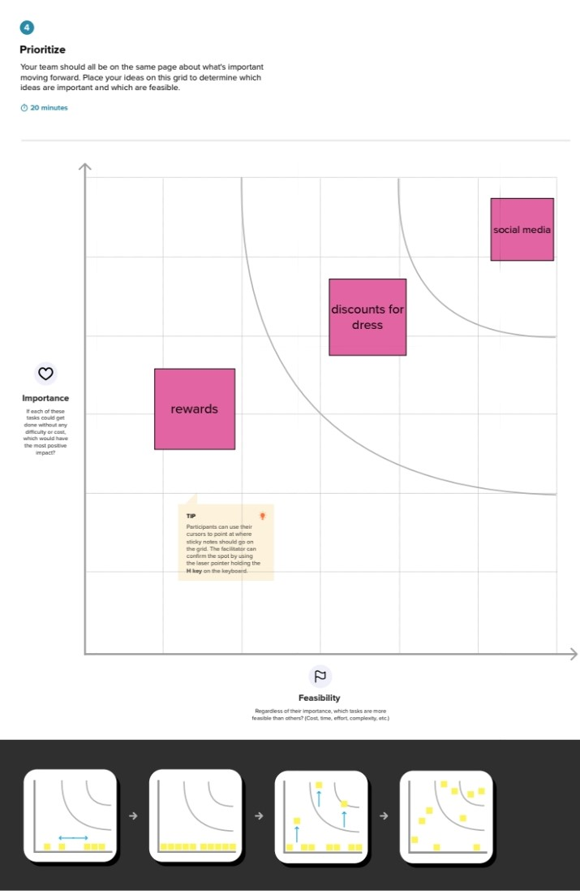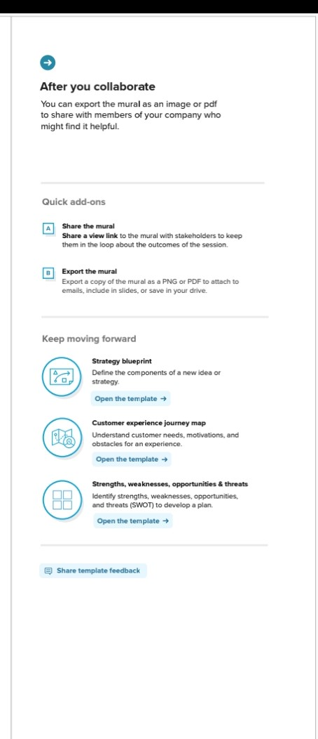

1. Result

3.1Data Model:

|  |  |  |
| --- | --- | --- |
| Object name | Field label | Data type |
| Tracking | Dispatched | Check box |
|  | Sales order | Master detail relationship |
| Ware house | Warehouse name and stock availability | Text |
|  | Product name | Text |
| contact | Account website | Formula |

3.2Activity and screen shots

Milestone 1:

Creating developer account

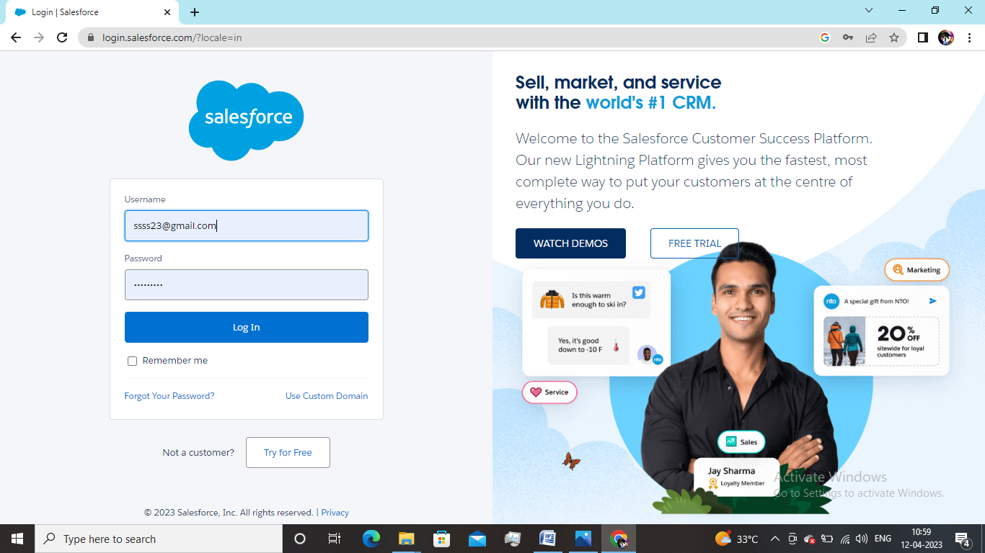

Milestone 2:

Activity 1- creation of object tracking

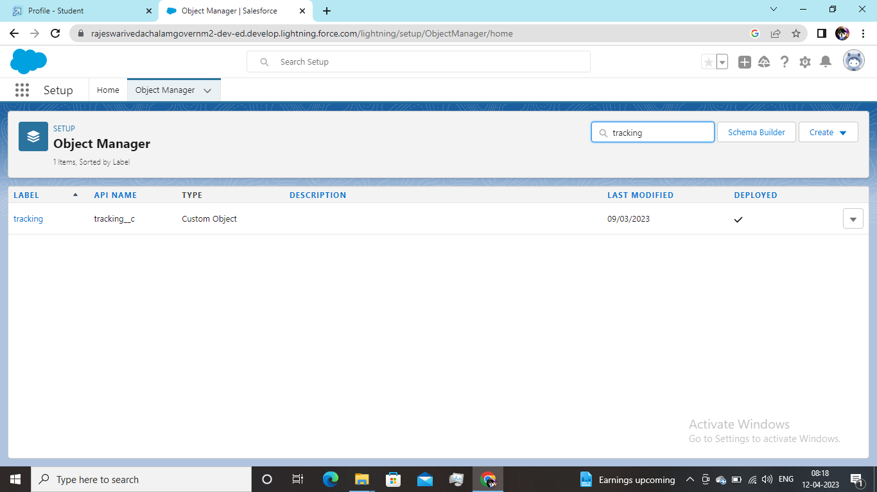

Activity 2- Creation of fields on tracking

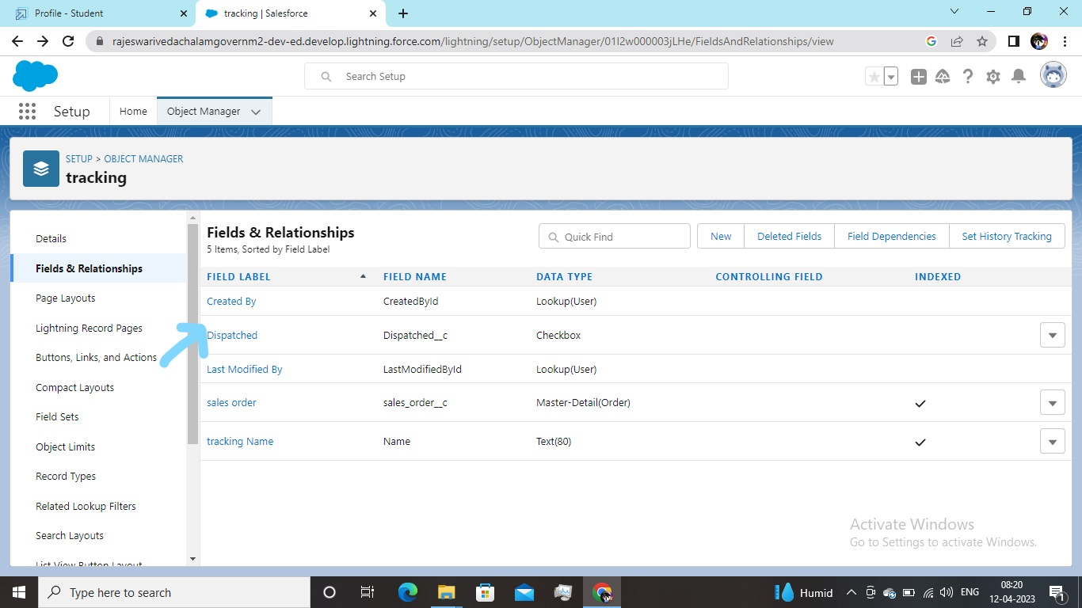

Milestone 3: Creation of relationship between objects

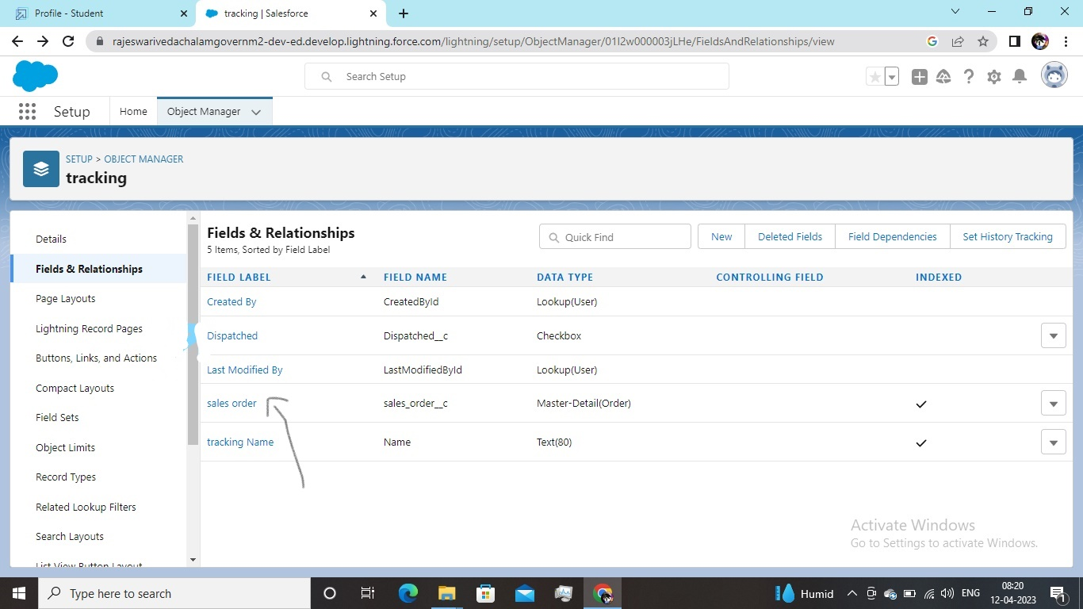

Milestone 4: Creation of application

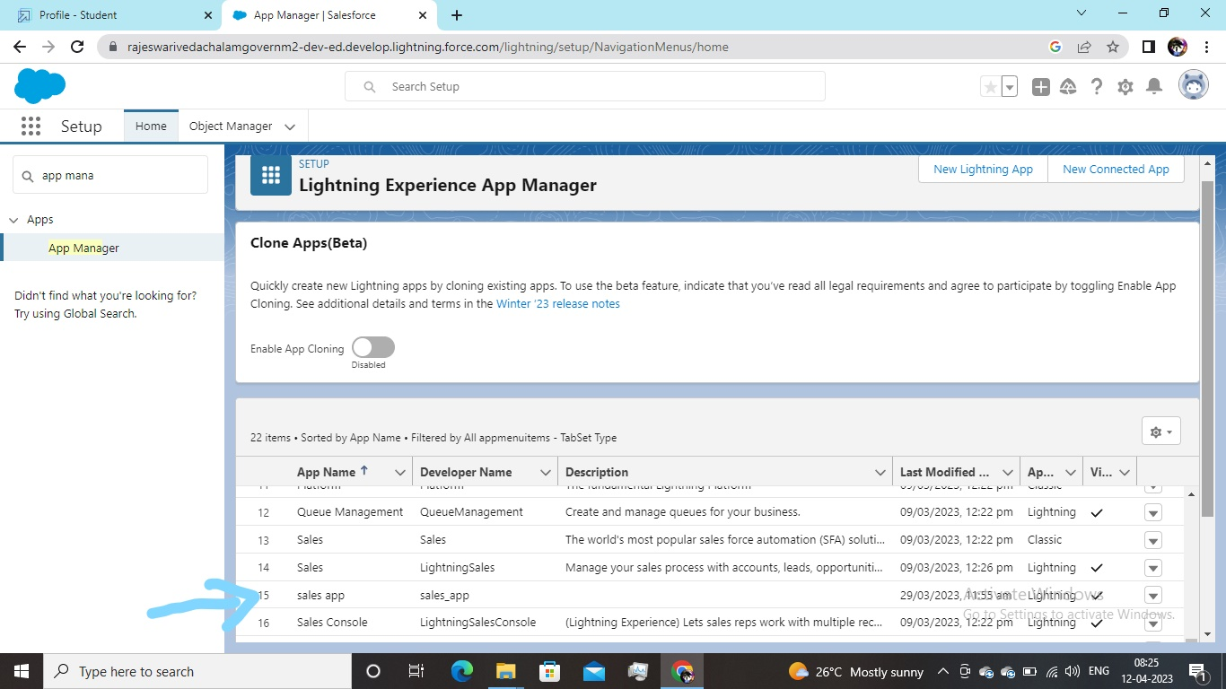

Milestone 5:

Creation of custom tabs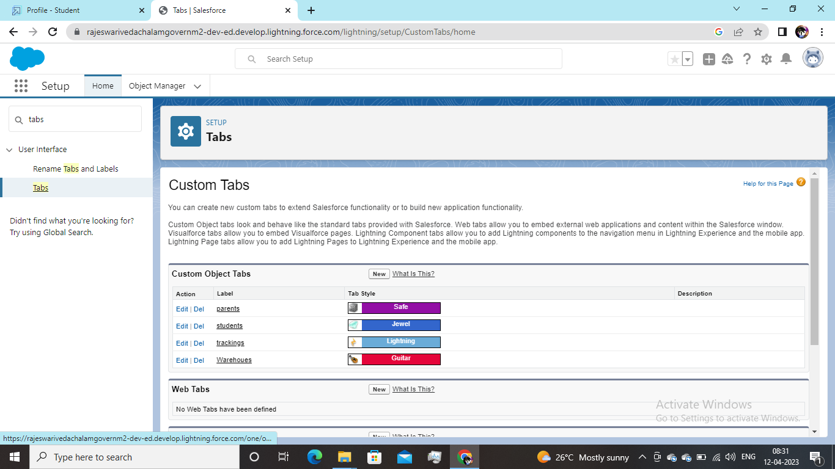

Milestone 6: Creation of user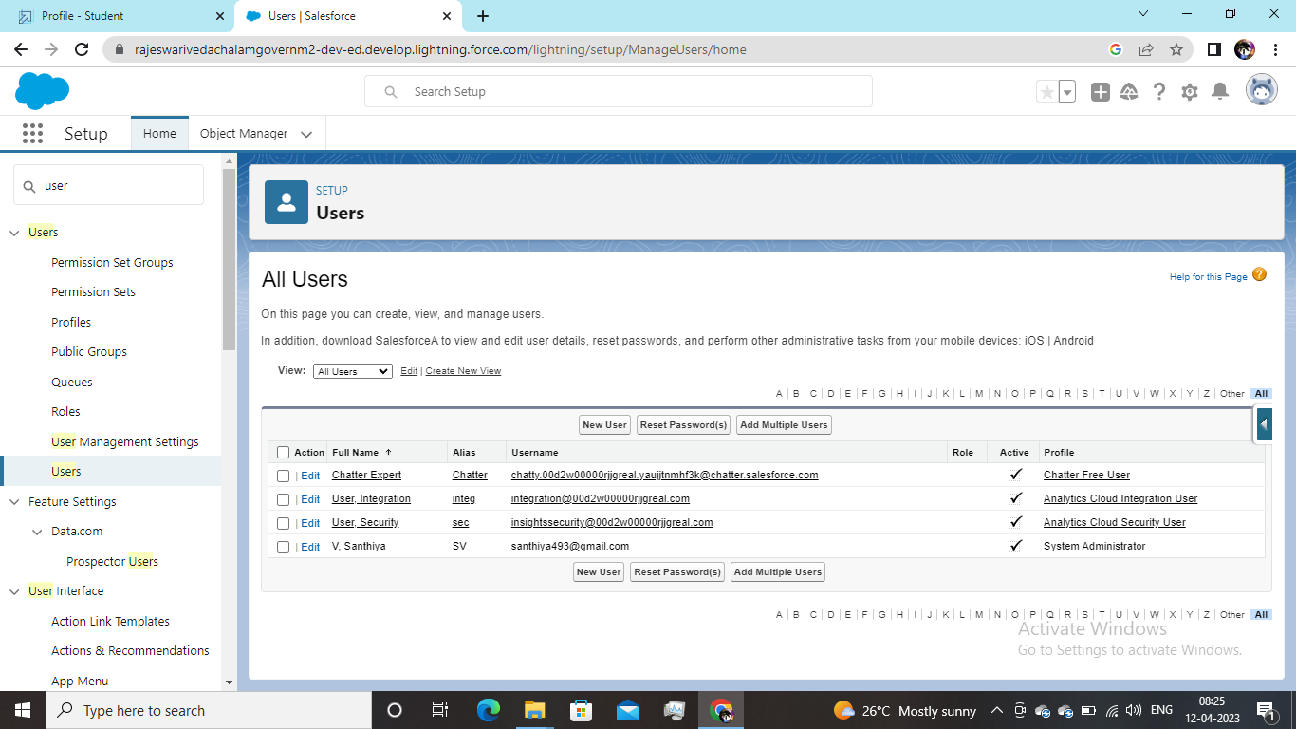

Milestone 7: Activity 1:

Creation of validation rule

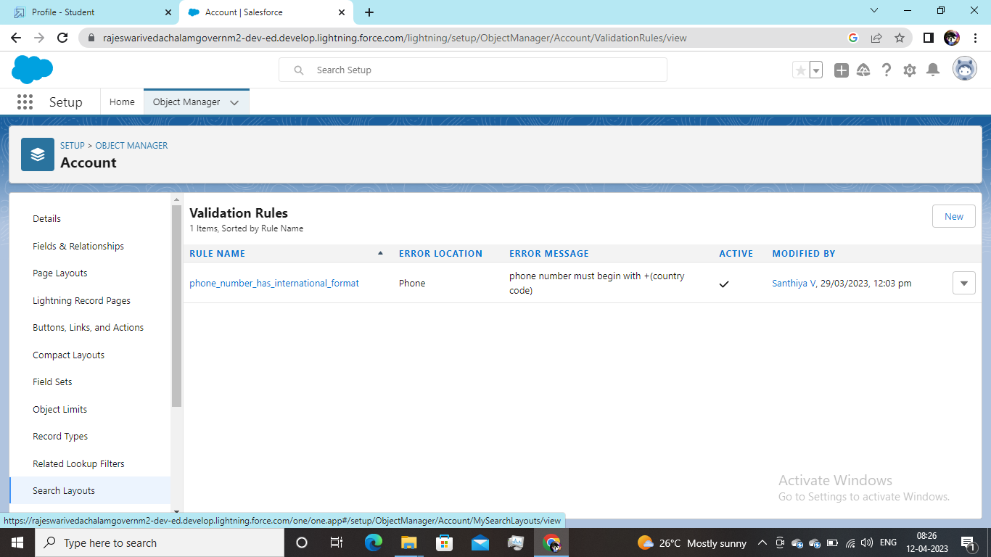

Activity 2: creation of cross object

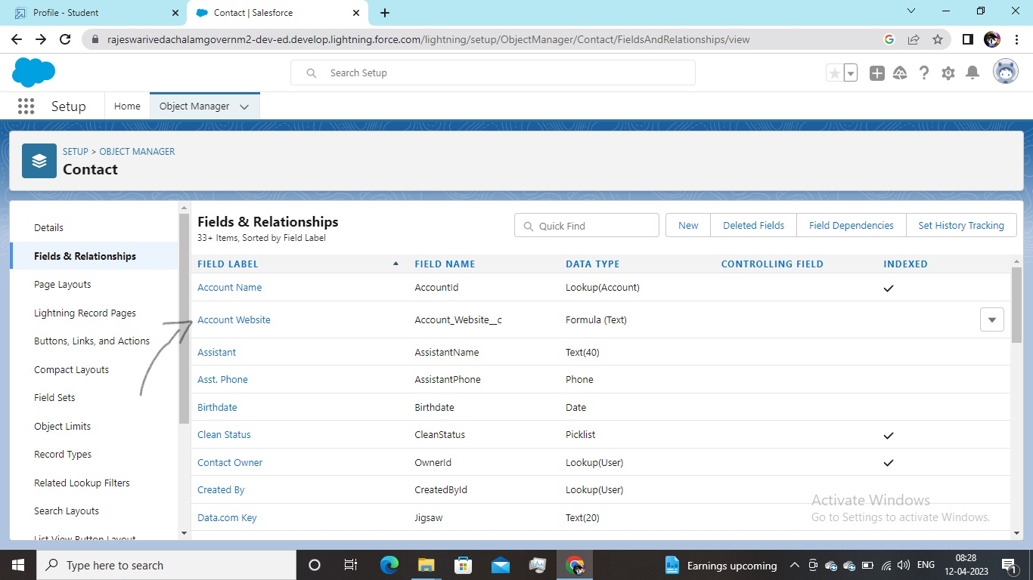

Milestone 8:

Creation of report

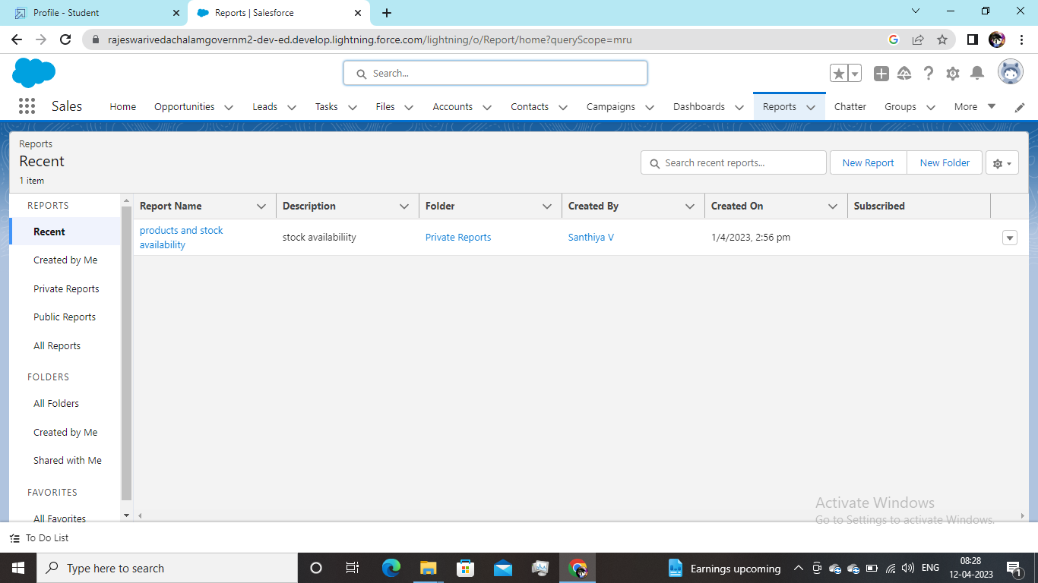

Milestone 9:Creation of dashboards

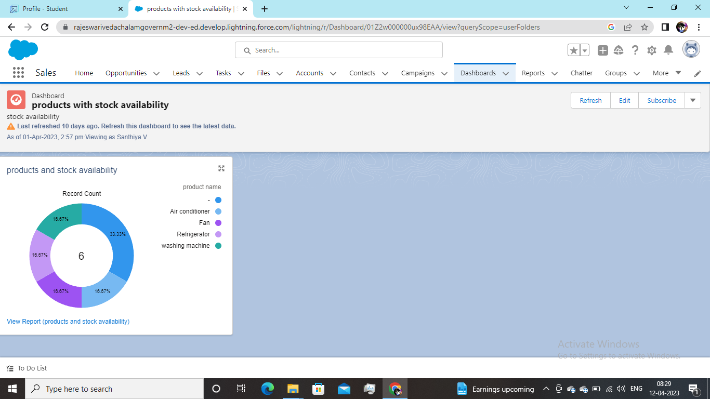

4. Trailhead profile public URL

Team lead-https://trailblazer.me/id/santv28

Team member 1-https://trailblazer.me/id/vijak47

Team member 2-https://trailblazer.me/id/sathm52

Team member 3-https://trailblazer.me/id/kavim48

5. Advantages and Disadvantages

With sales force, we can manage relationship with customers, collaborate and engage with the employees and partners and store our data securely in the cloud.

It also helps sellers identify the customers needs and preferences so we can respond at the right time.

6 . Applications

Our app can be used in

* All kinds of shops
* Small retail business
* Big store

7. Conclusion

We created objects and fields for our application and also corresponding tabs for the objects. We created a validation rule on account object on the phone field as required and also reports on warehouse. At last we finished creating our sales app and service app.

8. Future scope

Enhance the sales app and service app continuously to give customer more accurate results and services